Bridget  Dixon | Hartleigh  Rodgers |  | Bonny  Dunlop- Heague | Melissa  Jones | Melissa  Jones |  | Joanne  Stokes

CLUBHOUSE
Note: These are the ‘new’ yards, south of the clubhouse

Georgia  Sharpe | Sheree  Winter | Simone  Maree | Valmai  Buller | Sara  Trown | Julie  Millett
Georgia  Sharpe | Tiana  Woollams | Emma  Williams | Libby  Hubeck | Breanna  Brophy | Wendy  Brophy

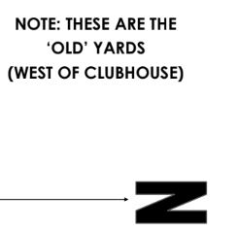

Note: these are the ‘old yards’ west of the clubhouse

