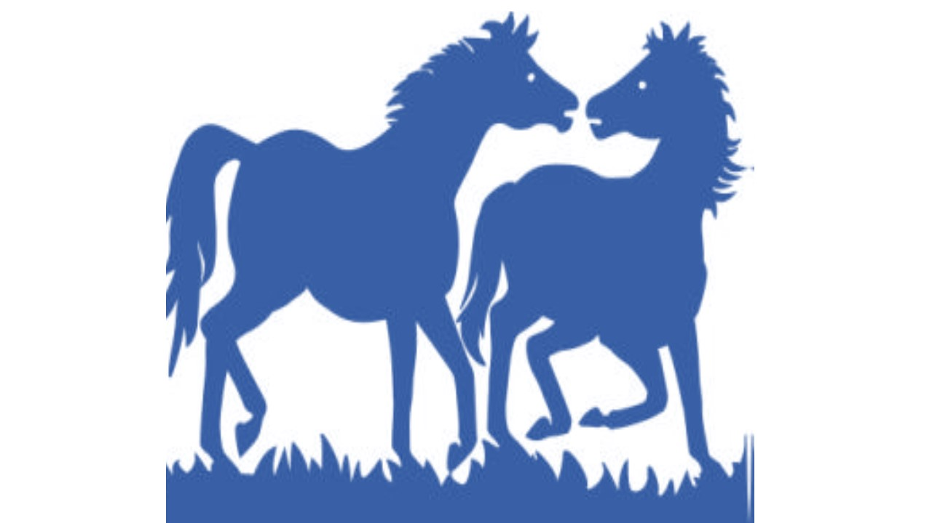BERRIMAH RIDING CLUB Inc.

EVENT AGREEMENT, RISK WARNING, RELEASE AND INDEMNITY (AGREEMENT)

BERRIMAH RIDING CLUB 2022 – NON-MEMBER EVENT WAIVER (applicable fee of $25/event)

ACKNOWLEDGEMENTS
1. I acknowledge and agree that:
a. taking part in horse sports is a dangerous recreational activity and serious injury (including spinal injury, brain or head injury, fractures, soft tissue injury and mental anguish and emotional disturbance) or death may result from participating in horse-related competitions or activities;
b. horses may act in a sudden and unpredictable manner, and EA and the Member Branch does not make any representations or warranties as to how a horse may act; and
c. I participate in any event held or managed by the Member Branch (and its affiliated clubs, associations and committees) (Activities), at my OWN RISK.
2. I have read, understood and agree to abide by this Agreement, all and any rules, regulations, policies and codes (including the Code of Conduct) of EA and the Member Branch, and any organiser or manager of Activities, as may be in force from time to time, and acknowledge and agree that:
a. EA and the Member Branch’s publication of any amended rules, regulations, policies and codes shall be deemed to be sufficient notice to me of the current rules, regulations, policies and codes of EA and the Member Branch; and
b. any misconduct (as determined by the Member Branch or the relevant Activities organiser, in their sole discretion) or refusal by me to follow any direction of the Member Branch or an Activities organiser, may result in my immediate disqualification from the Activities and the forfeiting of all fees paid in relation to those Activities.
RELEASE, INDEMNITY AND WAIVER
3. To the maximum extent permitted by law:
a. I waive all legal and equitable rights of action against EA and the Member Branch, including its officials, volunteers, medical personnel, members, employees, sponsors, promoters, advertisers, owners and lessees of premises on which Activities are held, underwriters, consultants and coaches (Associates), in regard to any claim arising from the Activities in respect of any injury, disability or death, whether caused by negligence, breach of contract or in any other manner whatsoever; and
b. I fully release, indemnify and hold harmless EA and the Member Branch and each of its Associates for any claim relating to injury, disability or death arising out of or in relation to the Activities.
4. I represent and warrant that:
a. in the event I feel unsafe or unwell in any way, I will immediately advise the Member Branch and the relevant Associates and will immediately cease to participate in the Activities;
b. I assume full responsibility and liability for any risk of bodily injury, death or property damage arising from participating in the Activities, whatsoever or howsoever arising;
c. if I have any queries about this Agreement, I have discussed those queries with the Member Branch, or otherwise sought my own legal advice and satisfied myself as to those queries;
d. I understand that my signature to this document constitutes a complete and unconditional release of EA, the Member Branch and its Associates from all liability to the maximum extent allowed by law in the event of me and/or the minor(s) or children under my care, suffering injury or death; and
e. I have explained the contents of this Agreement to the minor(s) or children under my care, who have in turn confirmed to me their understanding of the terms and effect of this Agreement.

_____________________________________ ____________________
NAME (BLOCK LETTERS) DATE OF BIRTH

_____________________________________ ____________________
SIGN HERE DATE

PARENT/GUARDIAN CONSENT FOR UNDER 18 YEAR OLD PARTICIPANTS.

_____________________________________ ____________________
NAME (BLOCK LETTERS) DATE OF BIRTH

_____________________________________ ____________________
SIGN HERE DATE

